Lezing 13 februari

^{Batteries not included}
Door Bram Jongepier
Senior Specialist, Studio De Voogt

A battery electric megayacht: why and how. Why should yachts be electric? Starting from the environmental impact and energy requirements a case is made for a future battery electric yacht. Using the current state of technology and extrapolating from there, barriers and opportunities are identified.

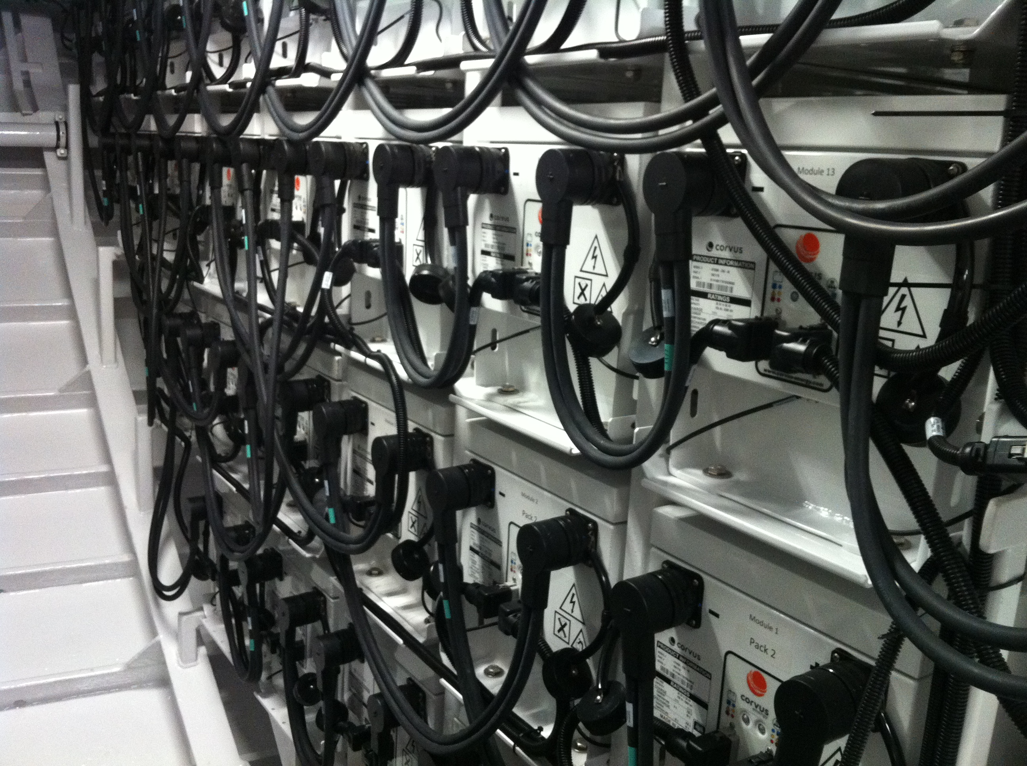

Practical information:
06:15 PM Supper sponsored by Studio de Voogt
07:00 PM Starting time for lectures
09:30 PM Closure

Location:
TU Delft, Faculty Room, Faculty 3mE - accessible through the entrance at Leeghwaterstraat 17, 2628 CA Delft.

